* **Objective**
* In this lab, Combinational Circuit Design will be studied. After simulating our circuit design at Vivado now we are going to built the circuit in the lab with using gates, breadboard and LEDs. LEDs is going to be our outputs to see the results.
* **Design Specification Plan**
* I will use three gates in my design which are a NOR, an OR, an AND, LEDS and an inverter gates and the 4-bit counter. First, I will be building up my circuit in the way such that 4-bit counter will be located at the beginning of the breadboard to generate 4-bit inputs. Then inverter and logic gate will be located at the middle of the breadboard and LEDs will be connected to the circuit at the end of the breadboard. After all that done, I will take the signals from the signal generator in the lab and LEDs will be turning on accordingly to the pattern in the truth table.
* **Proposed Design Methodology**

Truth Table

|  |  |  |  |  |  |
| --- | --- | --- | --- | --- | --- |
| S | C | R | H(S,C,R) | LED | Minterms |
| 0 | 0 | 0 | 0 | 1 | $$m_{0}$$ |
| 0 | 0 | 1 | 0 | 1 | $$m_{1}$$ |
| 0 | 1 | 0 | 0 | 1 | $$m_{2}$$ |
| 0 | 1 | 1 | 0 | 1 | $$m_{3}$$ |
| 1 | 0 | 0 | 1 | 0 | $$m_{4}$$ |
| 1 | 0 | 1 | 0 | 1 | $$m_{5}$$ |
| 1 | 1 | 0 | 1 | 0 | $$m_{6}$$ |
| 1 | 1 | 1 | 1 | 0 | $$m_{7}$$ |

Sum of products( minterms) $=\sum_{ }^{ }{m\left(4,6,7\right)=}m_{4}+m_{6}+m_{7}=H(S,C,R)$

$$H\left(S,C,R\right)=S.\overline{C.}\overline{R}+S.C.\overline{R}+S.C.R$$

$$=S.\overline{C.}\overline{R}+S.C.(\overline{R}+R)$$

$$=S.\overline{C.}\overline{R}+S.C$$

$$=S.(\overline{C.}\overline{R}+C)$$

$$H\left(S,C,R\right)=S.(\overline{C.}\overline{R}+C)$$

**Logic Schematic Diagram** 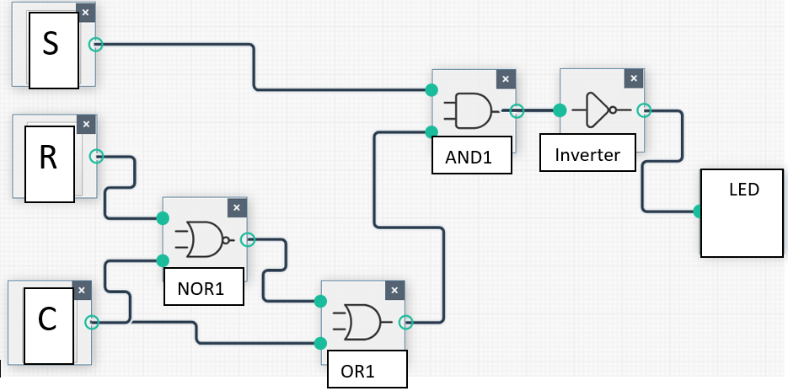

Gates:

